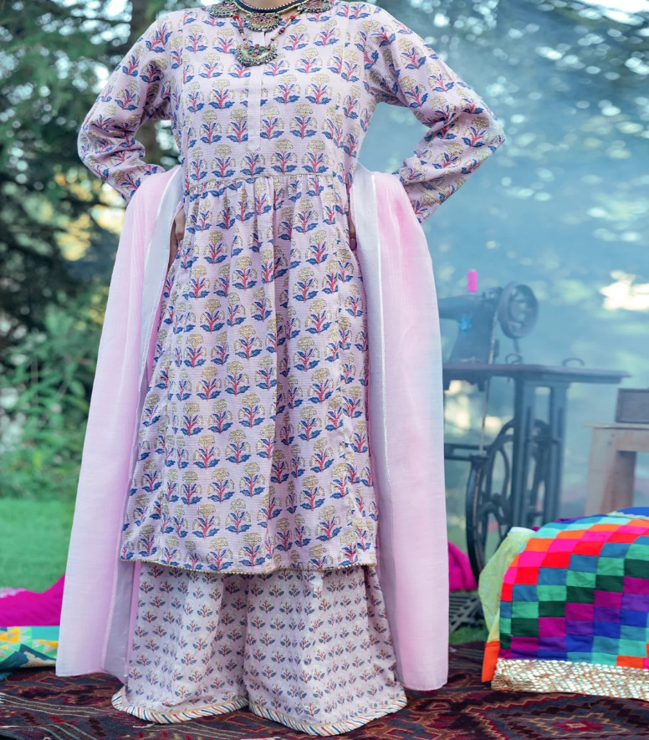

# LIGHT PINK CAMBRIC 3 PIECE STITCHED - AWP-3PS-576

Regular price~~Rs.11,250.00~~ Sale priceRs.8,437.50

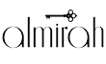

ADDITIONAL INFO

|  |  |
| --- | --- |
| Color | Light Pink |
| Pieces | 3 Pieces |
| Fit Type | — |
| Fabric | Cambric, |
| Season | Winter Collection |
| Disclaimer | Due to the photographic lighting & different screen calibrations, the colors of the original product may slightly vary from the picture. |